**PHOTOGRAPHIC ESSAY:THE IMPACT OF EDUCATION ON RURAL AFRICAN COMMUNITIES**

**Introduction**

Education is a powerful tool for personal and community development. In many rural African communities, access to quality education remains a significant challenge. This photographic essay explores the impact of education on these communities, highlighting the barriers to access, the efforts to improve educational opportunities, and the transformative effects of education on individuals and society.

1. **Barriers to Education**

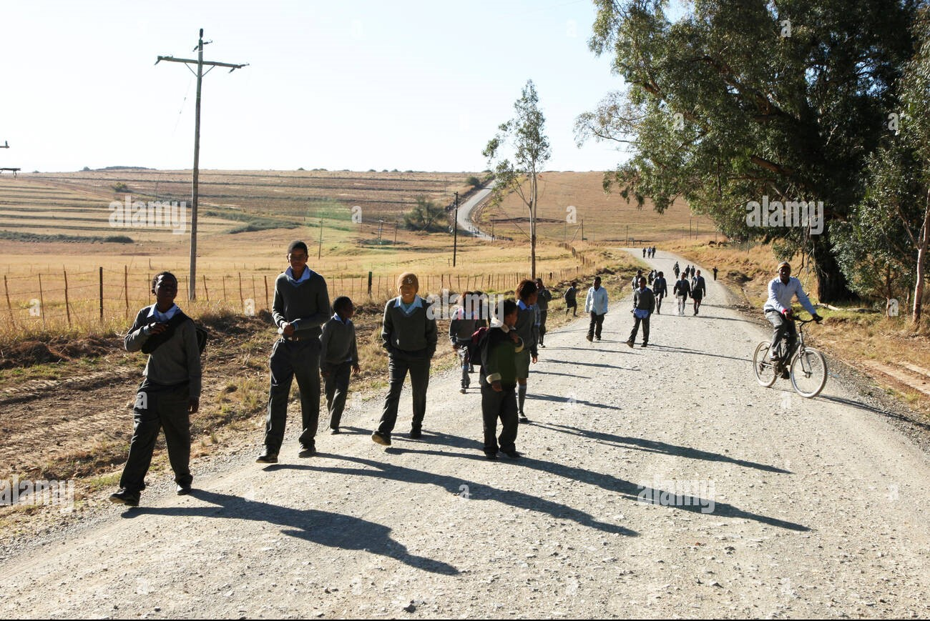

*Children walking long distances to reach their school*.

Many children in rural African communities face significant barriers to education. Long distances to schools, lack of transportation, and inadequate infrastructure are common challenges. These barriers can deter children, especially girls, from attending school regularly.

1. **Lack of Resources**

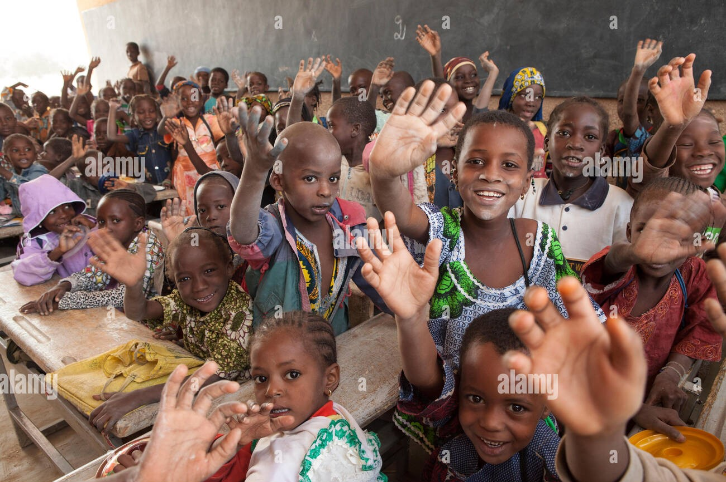

*A classroom with limited supplies and overcrowded conditions*

Schools in rural areas often suffer from a lack of resources. Classrooms can be overcrowded, and basic supplies like books, desks, and writing materials are scarce. This shortage hinders the learning process and affects the quality of education that children receive.

1. **Community Efforts**

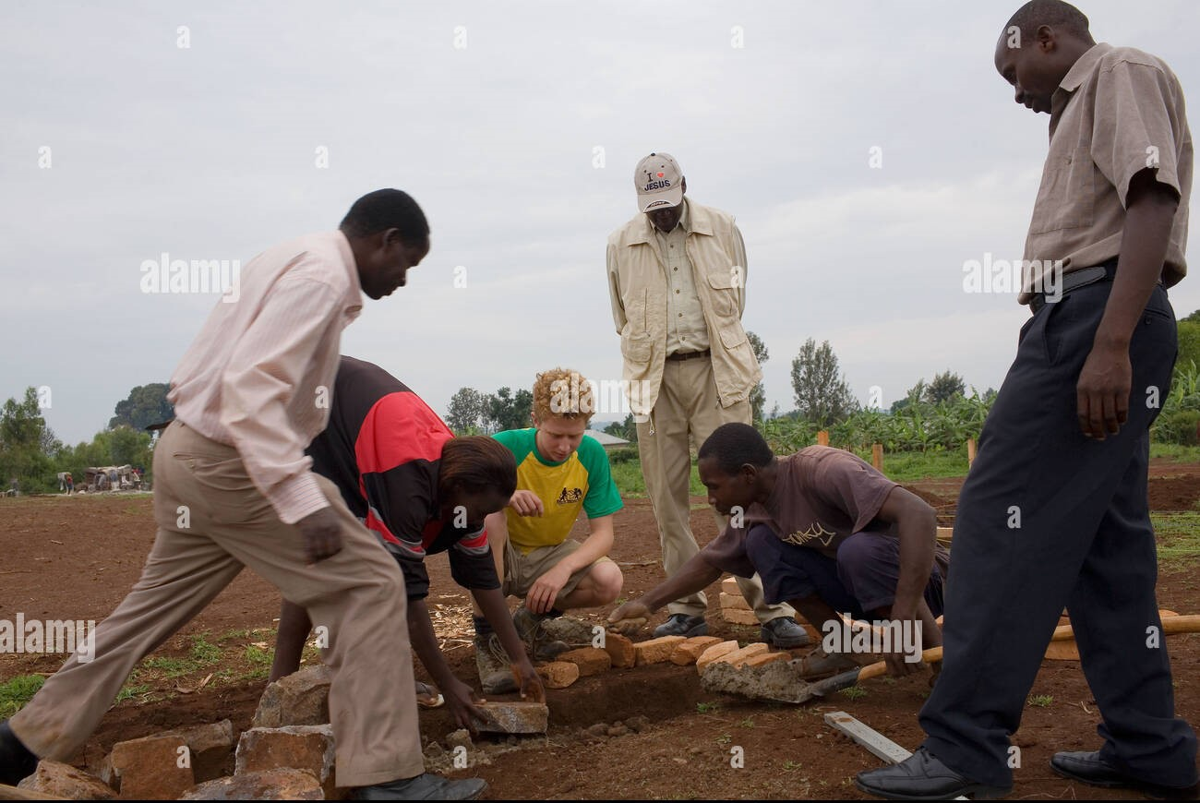

*Volunteers building a new classroom for a rural school*.

Despite the challenges, communities are taking action to improve educational opportunities. Local initiatives, supported by NGOs and government programs, focus on building new classrooms, providing supplies, and training teachers. These efforts are vital in creating a conducive learning environment.

1. **Empowering Girls through Education**

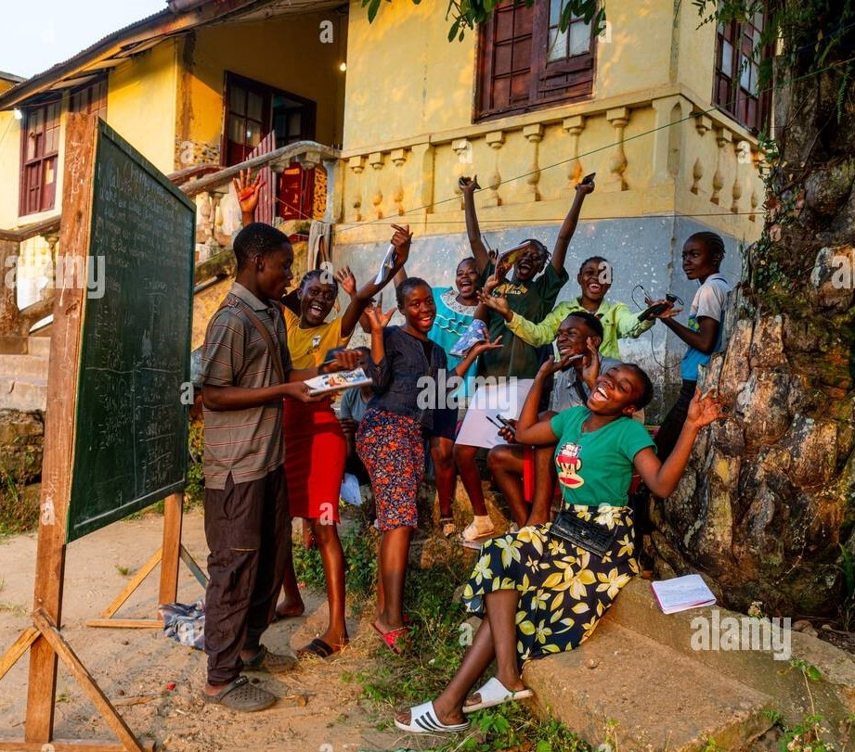

*A group of girls proudly attending their class.*

Empowering girls through education is a key focus in many rural areas. Educating girls leads to numerous benefits, including improved health outcomes, economic opportunities, and the breaking of cycles of poverty. Programs that encourage girls' enrollment and retention in school are making a significant impact.

1. **The Role of Technology**

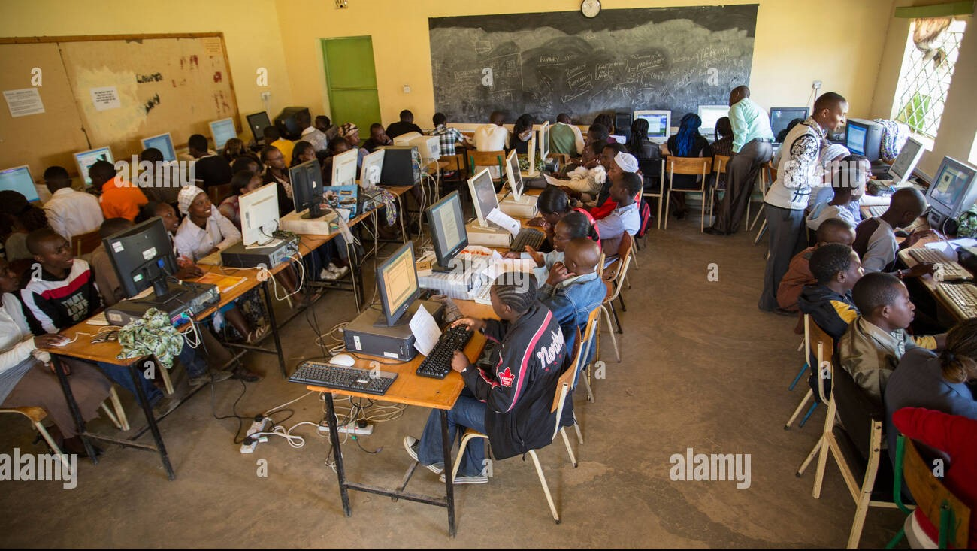

*Students using computers in a classroom setting.*

Technology is playing an increasingly important role in enhancing education in rural communities. Access to digital devices and the internet can bridge educational gaps, providing students with a wealth of information and learning opportunities that were previously inaccessible.

1. **Vocational Training**

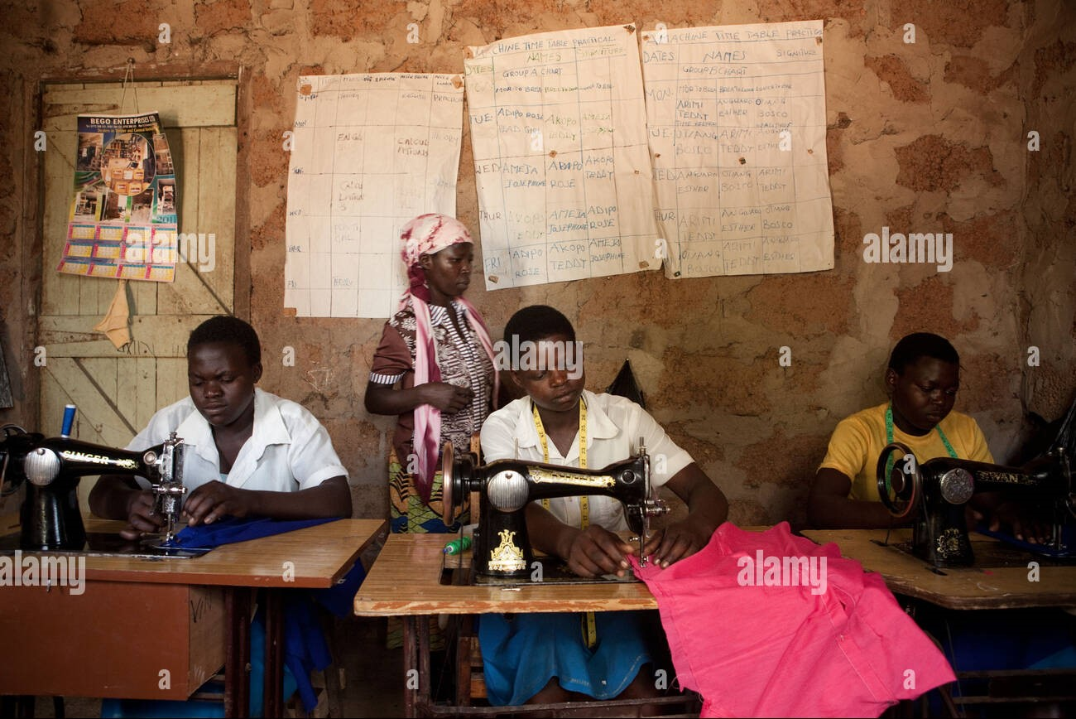

*Youth learning tailoring skills in a vocational training center.*

Vocational training is another crucial aspect of education in rural areas. Programs that teach practical skills, such as carpentry, sewing, and farming, equip young people with the tools they need to secure employment and support their families. This training fosters economic independence and community development.

1. **The Impact on Future Generations.**

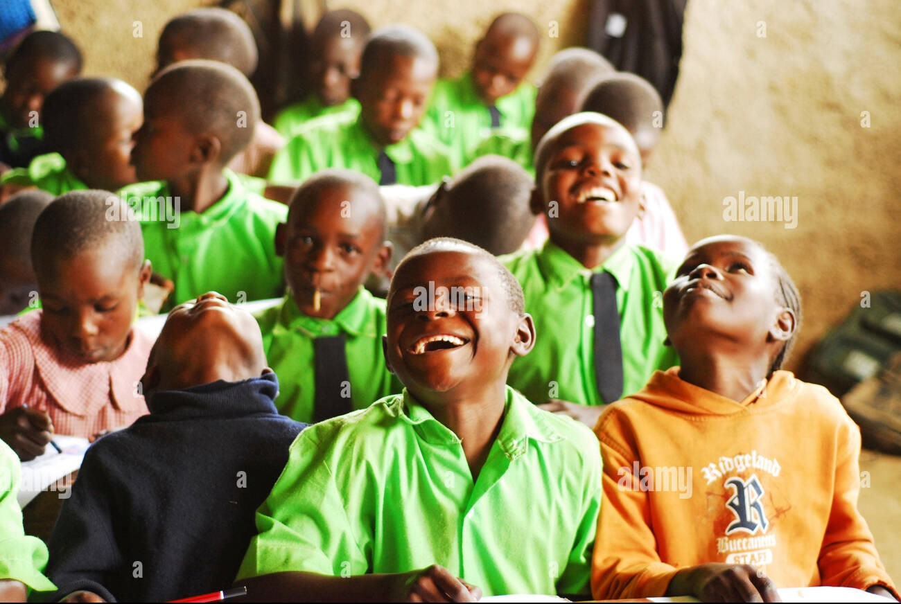

*Children smiling and engaging in a classroom activity.*

Education has a profound impact on future generations. Children who receive quality education are more likely to become active, informed citizens who contribute positively to their communities. They are also better equipped to break the cycle of poverty and build a brighter future for themselves and their families.

**Conclusion**

Access to education is a cornerstone for the development of rural African communities. While there are many challenges, the efforts of communities, educators, and organizations are creating significant improvements. By continuing to invest in education, we can empower individuals, foster sustainable development, and transform the future of rural Africa.